- 메인 포스터
“Super HI-rio Party”(가제)
 약간 이런 느낌쓰? 로 만들어봤어요

- 행사 소개
슈퍼 마리오 파티 컨셉의 운동회.
🌏 Hello, this is HI-Club! 🌏

This May, we are excited to invite you to HI-Club Sports Day! The concept is Super Mario Party. Let’s run, play, and make unforgettable memories together. If you want to join, please fill out the form below carefully. .

- 💚 Details

Who?
150 Exchange Students + HI-Club Members
Where?
Suwon Campus Field
Notice: In case of rain, the event will be held indoors at Suseong Hall (Suwon Campus). More details will be announced later
When?
2026.05.09. Sat. 10:00 - 18:00

☑️ Participation Fee
13,000 won (lunch included)

- 타임테이블 (04/13기준 최신화 예정)

12:00 ~ 13:00 | Headcount & Lunch
13:00 ~ 13:30 | Opening & Warm-up
Session 1
13:30 ~ 15:15 | 13:30 ~  14:55 | Tournament-style Game | 13:30 ~ 14:10 | Flip the tiles | Mini Game | 1) Jegichagi  2) Cham Cham Cham  3) Long Rope Jumping
 |  |  | 14:10 ~ 14:55 | Tail chase
 | 14:55 ~ 15:15 | Main Game | Pair Up
15:15 ~ 15:45 | Break Time
Session 2
15:50 ~ 17:35 | 15:50 ~ 17:05 | Tournament-style Game | 15:50 ~ 16:25 | Tug-of-War | Mini Game | 1) Ttakji Game  2) Limbo  3) Bottle Cap Flicking
 |  |  | 16:25 ~ 17:05 | Dodgeball
 | 17:05 ~ 17:35 | Main Game | Relay Run
17:35 ~ 18:00 | Score Announcement and Closing

- 점심식사 메뉴

For Vegan : Poke bowl, which is a fresh and healthy bowl packed with colorful vegetables and plant-based goodness.
For Non-Vegan : Pork cutlet bento box which is a hearty and crispy deep-fried pork cutlet served with rice and side dishes.

- 티셔츠 사이즈 안내
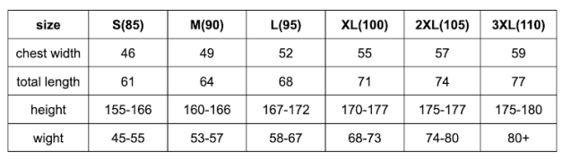

- ☑️ Important Notes
1) 🚫 NO ON-SITE Registration !!! 🚫
2) Please bring your own sunscreen and cap to avoid sunburns. ☀️
3) If you have any physical disability that may affect your participation, please let us know in the form.
4) In case of bad weather, the event may be canceled or postponed. (We’ll notify you in advance.

⚠️ Safety Rules ⚠️
1. Follow your team leader's and staff's instructions.
2. Avoid rough or dangerous play.
3. If you feel unwell, inform the staff immediately.
4. HI-Club will not be responsible for any lost or damaged items.

